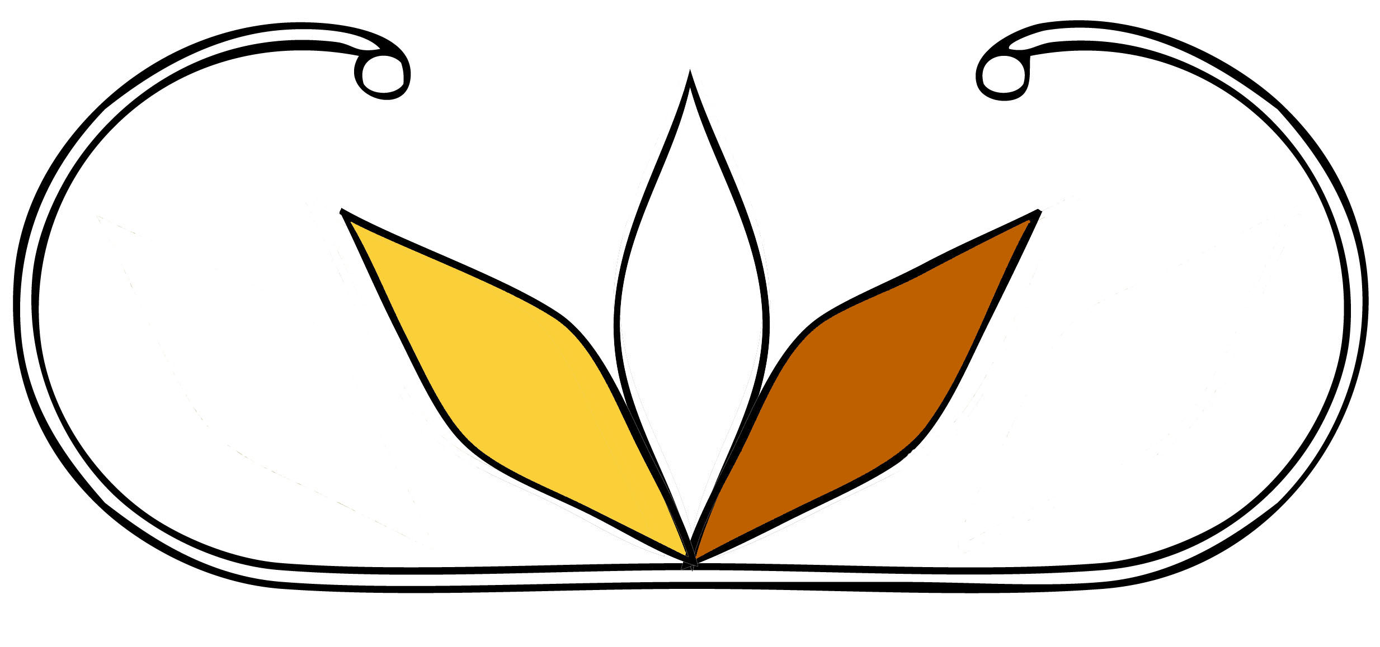

Ta'n Teli L'nuwulti'k

A Leadership Program
Based on Traditional Teachings

Knijannaq - Elmi'knik...

Mu mijua’ji’j kna’masik
ta’n kikmanaqik telpukwala’tisn,
ta’n wetapeksit,
ta’n teli L’nuit,
aq ta’n teli L’nui’sit...
Ma iapjiw kjiji’sik
aq ma kjijituk
ta’n teli knaq
Aq ta’n teli klu’k L’nuey.
Our Children - Our Future...

“Unless a person learns
about the forces which shape him,
the history of his people,
their values and customs,
their language,
he will never really know himself
or his potential as a human being.”
- Author Unknown

Ta'n Teli L'nuwulti'k

Council Fire Double Curve

Ta’n Teli L’nuwulti’k is symbolized by a double curve motif, representing life (mimajuaqn) on earth, from birth to death. The Wapna’ki Confederacy whose traditional lands are located along the Eastern Seaboard of Turtle Island has used this stylized design since time immemorial. The central part of the design signifies the Sacred Fire.

The colours used are the four sacred colours of the Wapana’ki Confederacy, black, white, yellow ochre, and red ochre.

In the past, our ancestors used the fire as a guiding force when the leadership made decisions based on prayer and spiritual direction.

The fire is also a representation of the Mi’kmaw Creation Story, the white flame representing Creator who is the Maker of Life, the yellow flame represents the Grandfather Sun who is the Giver of Life, and the red flame represents Mother Earth who sustains Life. Each one is connected to a fire, Creator has a Council Fire in the Spirit World, Grandfather Sun is a fire that gives light and warmth, and Mother Earth has a fire that burns deep within her. As well, the Sacred Fire keeps us connected to both the ancestors (the past) and the coming generations (the future) and still burns deep within our hearts and spirits as long as Mi’kmaw remain.

Ta'n Teli L'nuwulti'k

Mission Statement:

To inspire our Youth to become confident leaders initiating changes for an optimistic and positive future by empowering them with a strong sense of pride and identity that is established in the Mi’kmaw ways of being. All youth will have the opportunity to develop intellectually, spiritually, emotionally, and physically within the framework of Mi’kmaw culture, ideals, and ethics in conjunction with peers, elders and community mentors in a nurturing environment.

Vision Statement:

All people are endowed with individual gifts from the Creator that need to be recognized and enhanced so they reach their full potential as responsible and productive human beings with love and compassion for the sacredness of life.

We accept that Creator and the Ancestors are our source of strength and inspiration; their guidance coming from many sources including prayer, dreams, and in the words and deeds of others.

We acknowledge that we are all connected and woven together by the supportive threads of relationship: with one another, with Creator, and with the Earth and should always be motivated to focus on the collective wellbeing of all.

We are committed to fostering lifelong learning and achievement by creating an atmosphere based on traditional philosophy of leadership embedded in the Mi’kmaw worldview.

Motto:

“Our decisions impact the next seven generations.

Ta'n Teli L'nuwulti'k

Introduction:

Ta’n Teli L’nuwulti’k believes that all people come to Mother Earth with gifts and talents given by the Creator. Each of us is responsible to improve and develop those gifts to enrich our lives both collectively and individually therefore; we are committed to enhancing the lives and experiences of youth in a positive environment which promotes intellectual, academic, emotional, spiritual and personal growth.

Ta’n Teli L’nuwulti’k believes in the inherent goodness of humankind, which can be enhanced and mature if properly nurtured. We hope to accomplish this by promoting awareness of relationships and connectedness. By encouraging respect for self and others, everyone becomes accountable for their decisions and learns to accept responsibility for their choices because it has the power to impact both physical and spiritual realms.

We hope that our Ta’n Teli L’nuwulti’k Leadership Program will convey the idea that we expect and encourage the emergence of the very best warrior spirit for all individuals. We aspire to foster the belief that we are all sacred beings and deserve to be treated with respect, dignity and compassion. Furthermore, we will create dynamic and creative environments that provide learning opportunities and challenges focusing on a heightened awareness of self and others and our connection to each other. In reclaiming, revitalizing, reinstating and preserving our ways of knowing and being, we honour our Ancestors by leaving a living legacy of Mi’kmaw Identity and Culture. As we decolonize ourselves, our relationships to Creator, to Mother Earth, to the ancestors, to one another and to our spirits become stronger; we become responsible and productive citizens of the world guided by such values as love, respect, honesty, humility, courage, wisdom, and compassion in order to live in harmony with Mother Earth and all her children.

Ta'n Teli L'nuwulti'k

Rational:
Ta’n Teli L’nuwulti’k Leadership Program reflects our traditional values and beliefs, which are:
- We come to Mother Earth with gifts from the Creator and the Ancestors
- It is our sacred duty to discover and cultivate those gifts
- Each of us has a purpose
- All life is sacred.
- Everyone is born with the potential for leadership.
- We are essential to the world, therefore responsible for the future of the earth.
- All have the right to be trained in their own cultural environment.
- Youth should learn to accept responsibility for their behaviour and be aware of the consequences of their actions.
- Youth have the tools and resources to positively impact their communities.
- Everyone should develop personal and social responsibilities.
- We need to respect and honour the rights of others.
- We need to respect and honour the knowledge and wisdom of Elders.
- Co-operation with others should be carried out in a fair and reasonable fashion with caring, empathy and kindness for each other.
- Our best personal effort should be present in all our endeavours.
- We must take into consideration the unique circumstances of each situation.
- Behaviour is learned, therefore; all leadership personnel should model appropriate behaviour and respect all people, property and the environment.
- Humour is a gift for the spirit. It is to be shared but never at the expense of another’s dignity.
- Violence is to be avoided as a choice in conflict or in a response when angry.
- Learning takes place in different ways and we respect those diversities.
- Learning is a life long process happening with active involvement, safe risk taking, social interaction and cooperation.
- Adherence to the Seven Sacred Teachings: Love, Honesty, Respect, Truth, Courage and Strength, Wisdom and Truth.
- Ta’n Teli L’nuwulti’k Leadership Program is to help youth by preparing them for the future as caretakers of the land, peacekeepers, and knowledge holders of our culture.
- Ta’n Teli L’nuwulti’k Leadership Program promotes and develops the inner values and self-discipline required to act in a conscientious manner.
- Ta’n Teli L’nuwulti’k Leadership Program educates our youth to become responsible, altruistic, well-balanced citizens of the world.

Ta’n Teli L’nuwulti’k Leadership Attributes:

- Everyone has a role to play and everyone is important to the whole
- No one makes the exact same contribution
- No hierarchy of leadership
- Rooted in relationships
- All things have a purpose, place and worth
- Perpetual student of life, lessons are everywhere
- Ability to interpret events & to understand the immanent value of all thing
- Learning is voluntary and never ending
- Leadership recognition comes from external forces
- Leadership is an honour
- Image of leadership is one of humility and modesty
- Leaders do not self promote
- Deep connection to past and present
- Strong spiritual component
- Group decision making
- Interdependency of individual and their actions
- Interactive with all
- Collective decisions
- Accountability rests with all
- Speaks from the heart and spirit
- Speaks respectfully
- Listens with the heart and spirit
- Call to action is decentralized, organic and intuitive
- Non-interference means that a person defines trust as a willingness not to interfere in how others construct their understandings
- Value is placed on a person who can serve by using his or her gifts in any capacity, the person who does what needs to be done when it needs to be done, regardless of role or authority
- Does not seek to stand out or promote his/her advancement
- It is inappropriate to manipulate one’s image in glorifying ways or to be boastful
- Things happen when people are ready for them to happen, or are determined by the nature of events
- Leadership is not sought; rather it is given and then for a prescribed period of time or until a particular result is attained
- Shared values, the power of a vision, the ability to rally people to action
- Generosity and integrity
- Seeks balance in all things including self

Encouraging Positive Behaviour:

Research indicates that positive reinforcement is effective in creating responsible behaviour in youth. When their positive behaviour is acknowledged, they feel good about themselves and as their level of self-esteem increases, it produces a positive effect on behaviour and achievement.

Proactive Measures:

- Be a good role model by presenting the types of behaviour that you want others to exhibit.
- Praise and give acknowledge to others.
- Understand that other people's emotions and feelings are real and should be taken seriously.
- Let others know that what they say, think and do is significant or important.
- Remember that words can build or damage self-esteem.
- Set attainable goals for success.
- Give responsibility so people feel useful and valued.
- Define boundaries, set rules clearly and be reasonable and fair.
- Create a welcoming atmosphere for others so they feel significant.
- Celebrate other’s achievements and successes and inspire them to strive to achieve their best.
- Smile a lot and relish the many facets of human beings.
- Recognize and focus on the highlights in other’s lives.
- Encourage others by concentrating on their gifts and strengths.

